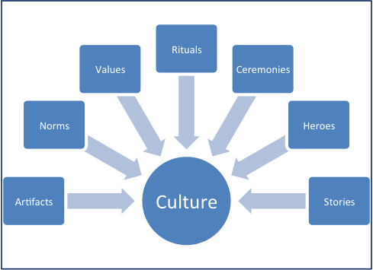

Again, as I mentioned in week 2 feedback, when coming from an educational background where I haven’t experienced the above vocabulary it takes a little time to understand them in context. But once again it has been interesting to broaden my horizons when thinking about cultural differences. Being an Irish teacher in Ireland, there is little cultural diversity in terms of nationality among staff members. This is mainly due to the fact that the Irish language is necessary to teach in public schools. However, dealing with children and parents from different cultural backgrounds is a reality and the recommendations supplied in Shaidul’s article, although not directed to primary schools, are still relevant.
Recommendations may be instrumental in minimizing cultural differences in international business encounters:
- Cultural awareness: Very important for teachers dealing with parents and children from other cultures. I find that there is a huge appreciation from children and parents if you acknowledge their diversity. In my case I use my Spanish to communicate with kids and parents. I also used the last five minutes in class on a Friday for “Polish lessons” where two Polish kids thought the class 5 words in Polish. This served to highlight the talents of these children and show that although their English wasn’t as good as the native speakers they had different linguistic skills. Also, for any teachers, you will know that EVERYTHING that happens in the classroom is reported back home. So taking this simple 5 minutes or saying a few words in Spanish is highly appreciated by parents also.

- Accept that cultural differences are as common as individual differences.
Shaidul mentions how “Strong curiosity and effort to know and study a culture may develop an ability to cope easily with cultural differences in international business.” In my opinion and from personal experiences this is only one side of the coin. I think the very fact you are making the effort to accommodate someone else’s culture is just as important as actually dealing with them. If a person sees you are trying to accommodate their culture they will often meet you half way.

- Develop a sense of cultural heterogeneity.
Jordan Peterson recons in “12 Rules for Life”. That people must be exposed to different cultures before they are 22 to truly be able to adapt. Even though Peterson has many outspoken views this is an interesting observation. He uses the example of recruiting people for the army before their sense of identity is formed. Before 22 it is easier to influence and shape a still malleable identity.

- Be flexible but retain your own identity.
I brought up an issue I experienced before when responding to Francesca’s post here.
I would see myself as very flexible and would be quite agreeable in most circumstances, however, I know that in the business world agreeable people more often than not don’t make it to the top. Steve Jobs was very disagreeable and very inflexible. Henry Ford the same. Are they the exception to the rule? Or maybe they had less international dynamics to deal with?
- Believe in win-win game
“Win-loss game ends up with retaliation by the loser/s. Therefore, businesspeople should stick to a win-win game in international business negotiation”, I see a link here between dealing with parents, of any cultural background. Parents often have complaints, I feel putting the foot down and being inflexible is the wrong path to go down. I’ve heard of parents having whatsapp groups and coffee mornings to ‘complain’ (I’m using a nice word here) about teachers. I have always had parents on my side. One technique I use is asking the question or making the statement “How are we going to deal with this” using that we almost always takes the wind out of an upset parents sails…..they are now part of the solution process, and if they are part of the process it creates this “win-win” scenario.

- Task-and purpose related focus
I once heard a six-year-old child comment “That’s because she’s black” about another child who was talking loudly. This came to mind when I googled the meaning of “ethnocentrism”: “evaluation of other cultures according to preconceptions originating in the standards and customs of one's own culture.” Unfortunately, this is not only a slip of a six-year-olds tongue, but a widespread problem in Irish society, and while we think we are moving away from this kind of attitude to different cultures, hearing a comment like this from a child is worrying.

- Create cultural synergy
“Each school has some uniqueness and in a multicultural perspective those uniqueness may yield new solutions to existing problems.” I hope you don’t mind me replacing the word culture with school here Shaidul ☺

Best wishes,

Have a nice week,

Canice

